Robot Building Competition 2023

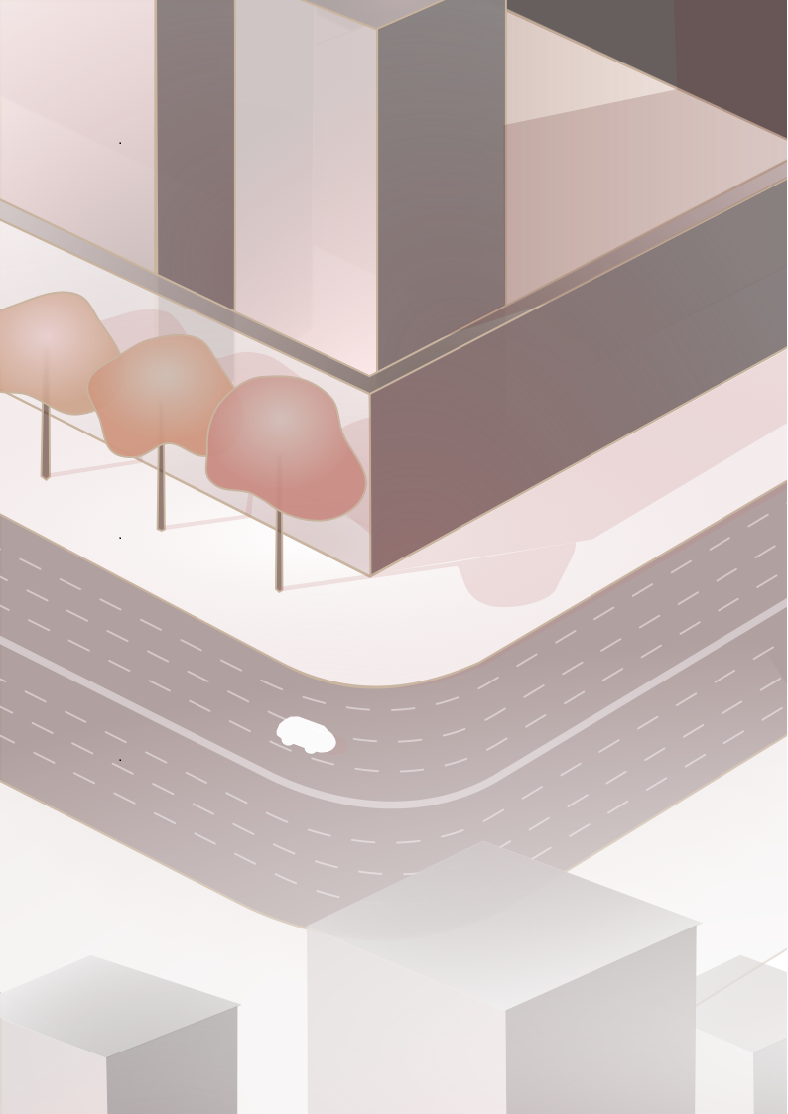



s[mee.club](https://smee.club/) | [mecc](https://www.monashclubs.org/clubs/Mechatronics)

# 

# 

# 

Competition Rules and Guidelines

Open Division

## 

Table of Contents

Introduction 3

Eligibility Requirements 3

Safety Requirements 3

Robot Requirements 4

Theme 4

Table 1 6

Qualification Maze 6

Procedure 7

Scoring 8

Competition Details 8

## 

## **Introduction**

The objective of the competition is to build a robot to navigate a maze, both in and out.

There are two mazes for you to complete: a qualifying maze, and the final maze. The qualification maze will become available for you to attempt it after lunch on Saturday. The final maze is hidden and will only be revealed to and attempted by the qualifying teams in each division, according to their performance in the qualifying maze.

## **Eligibility Requirements**

1. To be eligible for the competition, students should have bought a ticket and registered themselves into a team.
2. All teams have a maximum of 4 members.
3. Check your team’s division here:
   1. All teams are eligible for the Open Division.
   2. To qualify for the Junior Division, none of your teammates should have completed / be currently enrolled in a level 3 or higher ECE/TRC/MEC unit.

## **Safety Requirements**

1. Safety is of paramount importance when participating in this competition. All engineers should know what injury and damage to equipment and the environment occurs when the control of energy in a system is lost.
2. As appropriate, protective clothing, footwear and safety glasses should be worn by students when working on systems during construction, testing and competitions.
3. It is better to ask demonstrators for assistance rather than risking your safety and of those around you.
4. Any behaviour deemed hazardous or unsafe may result in immediate disqualification.
5. Tools like scissors, pliers, etc must be handled with care. You can always ask for assistance.

## 

## **Robot Requirements**

1. The robot must be constructed using the parts provided to each team in their kit and others made available to competitors by the organisers. You do not need to use all the components. Spare components like jumper cables are available on request.
2. Each robot must not exceed 25cm x 25cm in size. All robots will be inspected before they are allowed to attempt any maze. Maze cell size is 40cmx40cm.
3. No robot shall be powered with over 9 Volts of battery.
4. External materials, equipment and tools not in the kit are prohibited, unless approved by a competition official. Aesthetic-only materials are allowed, and students are encouraged to ask a demonstrator if they are unsure about what materials are permitted.
5. The robot must be physically constructed over the competition weekend, the 19/08/2023 and the 20/08/2023, between the hours of 9:00am to 5:00pm.
6. Any code written before the competition weekend is allowed, and may be used on the robot.
7. Each robot must be fully autonomous, i.e. once it has started moving in the maze, it cannot be interacted with until it has finished or is disqualified.
8. The robot must not ram into the maze.
9. Use of generative AI is permitted.

## **Theme**

A deadly gas leak has put the city 🌆 into lockdown. The cure to the leak lies in the heart of the city - the epicentre itself! No humans can travel on the roads as it is far too dangerous for a mortal—fortunately, your engineering skills can help save the day! Can you and your team build an autonomous robot 🚗 that will traverse the labyrinthine cityscape to release the antidote and make it back in the least possible time?

**The Challenge (Open Division)**

The main challenge involves your team’s robot navigating a 6x6 maze autonomously. Your robot will start at a starting cell as marked in *Figure 1.* The robot needs to navigate to the destination cell while avoiding any obstacles such as the walls. You need to indicate that you have successfully reached the destination cell by blinking an LED on top of your robot, twice (for 1s with a gap of 1s)

**Maze cell size is 40cmx40cm.**

.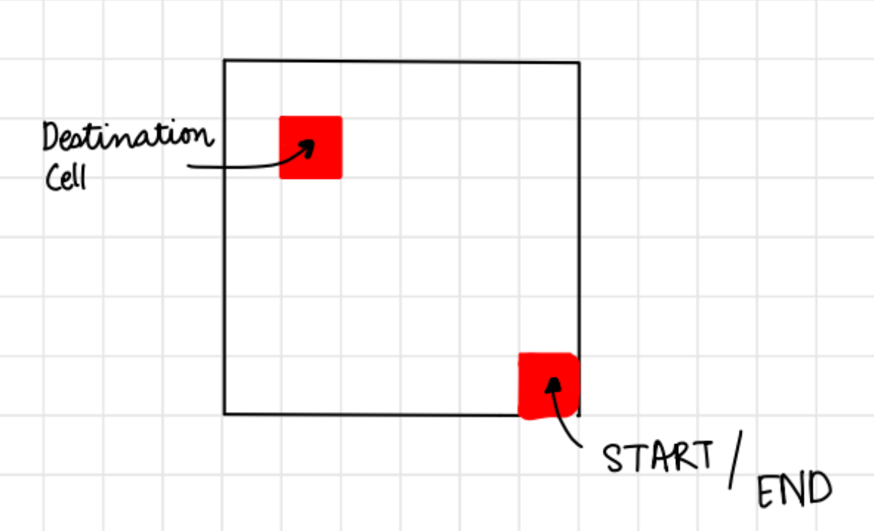

*Figure 1: Locations of Start/ End and Destination cell.*

Short cuts are to be accessed *only on the way out*. You will be risking the physical safety of your robot should you attempt to access the short-cut on the way in. All teams will have a time limit of 8 minutes. You may get up-to 3 attempts, however no additional time will be provided. Your maze-official will instruct you to press the reset button on your Arduino prior to each attempt. You may modify your code for sensor calibration *only* under the presence of an approver. We will ask you to upload the code in front of us. It is advisable for all teams that they calibrate their sensor at the venue of the final competition.

The maze will have a few movable walls that act as a gate. The two cells on either side of the movable-wall will be uniquely coloured for each gate. You may note the gate’s location on the way in, and may prioritise which path to take on the way out. The cells surrounding the gates could be of the following colours: green, blue, purple, yellow

The destination and start/end cell will be of red colour.

To ease cell-tracking, all the other cells will follow a chequered pattern (black and white). Additionally, note that all cells in the 6x6 maze will be accessible. That is, none of the cells will be blocked on all four sides.

Have a look at *Figure 2 as an example of a sample 4x4 maze.*

***Unlocking gates***

Once you have reached the destination cell, you may access the short cuts. To open a gate you have to be at that gate’s uniquely coloured cell, and send out a unique message according to *Table 1.*  You also need to blink your LED once *for three seconds.* Should we see any of the gates opening, without being on the cell attached to the movable wall, it will result in immediate disqualification. You will be provided with a MAC address that you must connect to 5-10 minutes before your turn.

|  |  |
| --- | --- |
| GATE COLOUR | MESSAGE (as a char) |
| Blue | ‘1’ |
| Green | ‘2’ |
| Purple | ‘3’ |

## *Table 1*

## **Qualification Maze**

Before we call your robot to be evaluated on the challenge maze, we ask you to call our demonstrators before 12 PM on Sunday, to showcase your robot’s driving and navigational skill on the Qualification Maze. You will have access to this from 1:15 PM on Saturday.

Meanwhile, feel free to use any of the available calibration tracks for calibrating your turns.

A layout of the Qualification Maze can be found below.

There will be two copies available. One will have chequered and coloured cells, with movable walls enabling you test out the complex parts of the challenge with wireless communication. However, **in order to qualify for the challenge maze, all you need to do is demonstrate that your robot can smoothly navigate the entire maze from start cell to destination cell. It should be able to detect the RED start / destination cells, and blink an LED when you have reached it. It should not take more than four minutes.**

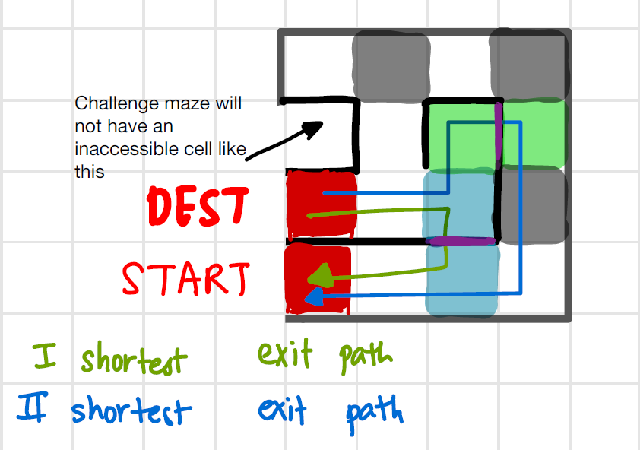

*Figure 2: Copy 1 of Qualification Maze*

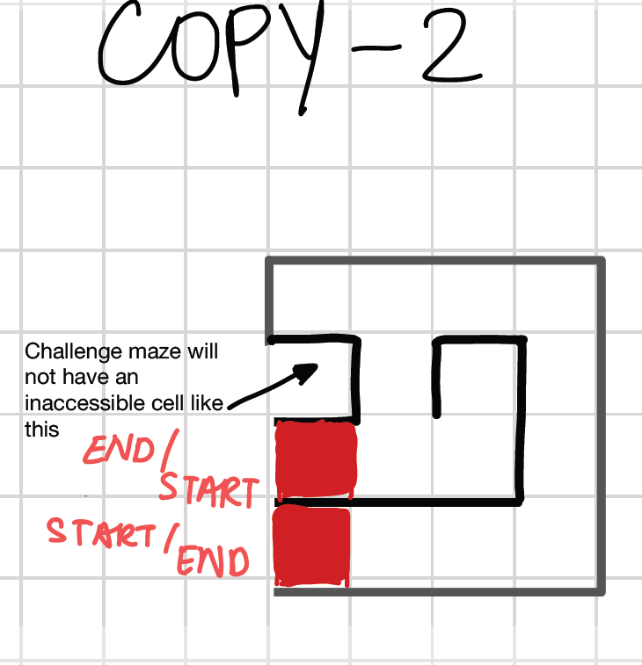

*Figure 3 : Copy 2 of Qualification Maze*

## **Procedure**

1. You will have access to the qualification maze from Saturday 1:15 PM to Sunday 11:45 PM. It is your responsibility to call a demonstrator over to demonstrate your robot’s driving and navigation skills on the qualification maze. It should not ram into walls, it should not get stuck in dead ends unnecessarily long. It should be able to make its way from start to end, including the reverse order.
2. After lunch on Sunday, qualifying teams will be assigned time slots to attempt the final maze.These time slots will be determined based on performance in the qualifying maze. Unqualified teams will not get a chance to be evaluated at the challenge maze.
3. We have a short margin to judge all competing teams. Please communicate with us, and follow our instructions promptly as we commence evaluation of the robots. If you think your team may hinder the flow of the competition, or if you have any kind of issue, please communicate with us.
4. You will have a 5 minute set-up time once you report to us as we call out your name. You may calibrate your robot one final time in the challenge zone should you need to.

You will be required to connect to our provided MAC address if you would be attempting to open up the gates on the way out.

1. You will have up-to 8 minutes on the challenge maze. You may reset your robot up-to 3 times, no additional time will be given for that. The arduino will be reset by us in between attempts. Any changes in the code, or a calibration will be under the supervision of an approved person.
2. The decision of the maze-officials will be final and undisputed.
3. The rules mentioned in the Robot Requirements section must be followed.

**Scoring**

1. Teams that perform all competition tasks will have a higher chance of winning than others. Specifically this includes reaching all the way to the destination cell, indicating that the robot has reached the destination cell, navigating back to the starting cell and indicating that it has reached there.

2. Amongst the teams that meet the above criteria, the team to have the shortest total time will win.

**Further clarifications**

1. Ensure your team attends the challenge reveal presentation on Day 1 and morning briefing on Day 2
2. Post in anonymous forums.
3. Ask demonstrators for help.